
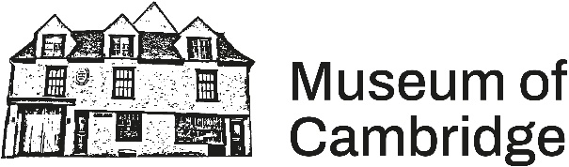

Legacies of Windrush - Windrush Curator

The Museum of Cambridge and our community partner Dr Carol Brown-Leonardi are looking for a group of Windrush Curators for a paid opportunity to share, learn, and curate an exhibition on the Windrush generation.

The Windrush Curator opportunity is open to anyone aged 16 – 25 with a connection to the Windrush generation. Whether you have always loved museums or have never stepped foot in one, this opportunity invites you to come and take part in a series of workshops where you can share your stories, develop new skills, and contribute to a celebration of the Cambridgeshire Windrush generation.

Part of being a Windrush Curator will be listening and reflecting on the oral histories of Cambridgeshire Windrush Elders to help shape an exhibition at the Museum of Cambridge. In these workshops, the group will explore the legacy of Windrush and come together to tell the story of Windrush in Cambridgeshire. You’ll be involved in deciding and designing the exhibition, deciding which objects to include, how they are written about, and inputting on what kinds of events we run to go alongside the exhibition.

As a Windrush Curator, you will:
- Have lived experience of Cambridgeshire and may have a connection to the Windrush generation.
- Be passionate about celebrating Windrush Elders stories and the cultural contributions of the Windrush generations to the United Kingdom.
- Be aged 16 – 25.
- Have an interest in learning about storytelling in museums.
- Be excited about working with a group of other Windrush Curators to get creative in designing an exhibition.

What are the commitments?
- Ideally, you’ll be able to attend a workshop once a week for around six weeks. However, we know life happens, and work, family, and health take priority. If you can attend a minimum of two workshops between December and March, we will do our best to support you and be flexible where we can.
- Be interested in one or both of the following:
- Sharing your own experiences of the Windrush generation that will contribute to the exhibition at the Museum of Cambridge.
- Eager to learn how to curate an exhibition. This could include having a creative approach to transforming a blank room into an intriguing and inspiring exhibition space, responding to the Museum’s recorded oral histories of Cambridgeshire Windrush Elders, creating object and exhibition information, and having the interest to research personal items loaned from Windrush Elders as well as collections from the Museum of Cambridge and beyond.

What will you get out of it?
- Work alongside museum professionals who will assist you in learning new skills in curation, caring for museum collections, and working with the public.
- Meet like-minded Windrush Curators and work together collaboratively.
- Contribute to an exhibition that thousands of visitors will visit at the Museum of Cambridge.
- Have the space to explore and share your own connections to the Windrush generation.
- At a minimum, receive £20 per hour of participation across the project, including travel costs, paid at the end of the project.

Applying
To apply for the opportunity, please fill out the form linked on the website at museumofcambridge.com/opportunities and submit it to Beau Brannick, the Project Officer—Legacies of Windrush, at beau.brannick@museumofcambridge.org.uk.

