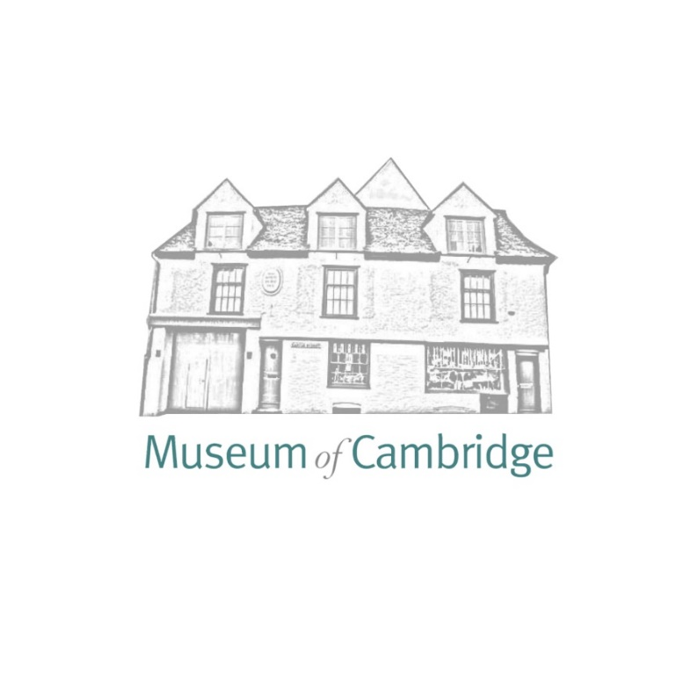
Museum of Cambridge Christmas Market - Call for Vendors

The Christmas Market takes place on:
Friday 29th November 2024 10:00AM – 5:00PM
Saturday 30th November 2024 10:00AM – 5:00PM
Sunday 1st December 2024 10:00AM – 5:00PM
Location:
Enid Porter Room, Museum of Cambridge, 2-3 Castle Street, Cambridge, CB3 0AQ

What kind of Vendors would we like?
Successful applicants will be those with locally made or especially unique products as the Museum of Cambridge is committed to supporting Cambridgeshire artists. Products with historical references, traditional looks, and techniques looks are highly welcomed. As this is a Christmas Market, items geared towards gifting, as well as those with a seasonal theme, are encouraged. Our vendors will share our goal of creating a festive and creative experience for our customers.
While we primarily want to use the Christmas market as an opportunity to showcase new suppliers, we will reserve a limited number of stands for our regular suppliers. When selecting vendors, we will be focusing on offering our visitors a diverse mix of product types and price points to ensure a rich and varied shopping experience.
Successful vendors will be notified as soon as possible after the deadline which is Monday 23rd September 2024.

What will be the cost of attending?
Per day is cost is £50 per day, £150 for 3 days.
Half of the fee is due when your stall is confirmed, and the second half is due 2 weeks prior to the event.
What is included in the fee?
- One table (dimensions 120 cm x 80cm) You will be provided with two chairs.
- Email promotion to 1,500 circulation list
- Social Media promotion to combined 14k followers
- Two free museum passes per table

Vendors are responsible for reading and understanding the terms and conditions of room hire located on the Venue Hire section of the Museum’s webpage, this sets out general expectations regarding conduct, health and safety etc. By completing this application, you acknowledge that you will adhere to this guidance. (note please disregard references to hire fees).

Please fill in the form below and return by email.
Contact name:
Company/Brand Name:
E-mail:
Website:
Facebook:
Instagram
Twitter:
Address:
Products (please describe your wares/the products you will have on the stall, including price). Please also attach photos of your products and a stall display, if you have sold before:

Dates you wish to attend:
Friday 29th November 2024, 10:00AM – 5:00PM
Saturday, 30th November 2024, 10:00AM – 5:00PM
Sunday 1st December 2024, 10:00AM – 5:00PM

The form may be returned by email to Sum Yin Wong, sumyin.wong@museumofcambridge.org.uk

